# Send results script notice

The general principle of the script is described in the figure below:

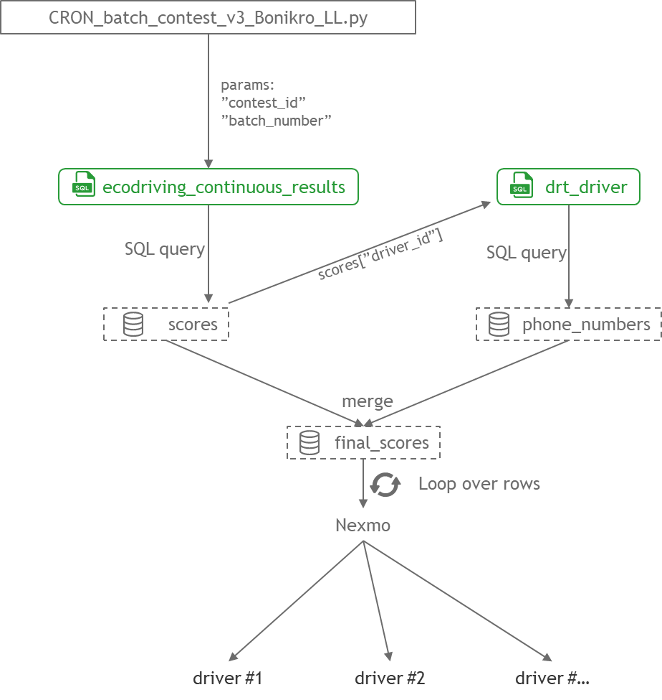

The script extracts the scores and the phone numbers from the tables “ecodriving_continuous_results” and “drt_driver”, respectively.

To know which scores to extract, the relevant “contest_id” and “batch_number” come from the script “CRON_batch_contest_v3_Bonikro_LL.py” and are called at the beginning of the script:



Then, the scores and phone numbers are merged in a single data frame called “final_scores”. Each row of this data frame corresponds to the scores of a single driver.

Therefore, the script then loops over all rows of “final_scores” to:

1. Prepare a message with the scores of the driver of the row
2. Send the message to the driver via Nexmo

To get a better grasp of what the script is doing, one may access the following Jupyter notebook:

**“…/Dropbox/Jupyter/Notebooks/Eco-driving%20-%20Loic/6.Send_drivers_feedback_VPS_v1%20-%20Bonikro_LL.ipynb”**